**Screenshots of the assignment: I have applied some bootstrap and CSS styling to the final functionality to get some good look and feel, the page design is derived from one of my previous works. Hope this helps as a disclaimer. ☺**

**Search Text**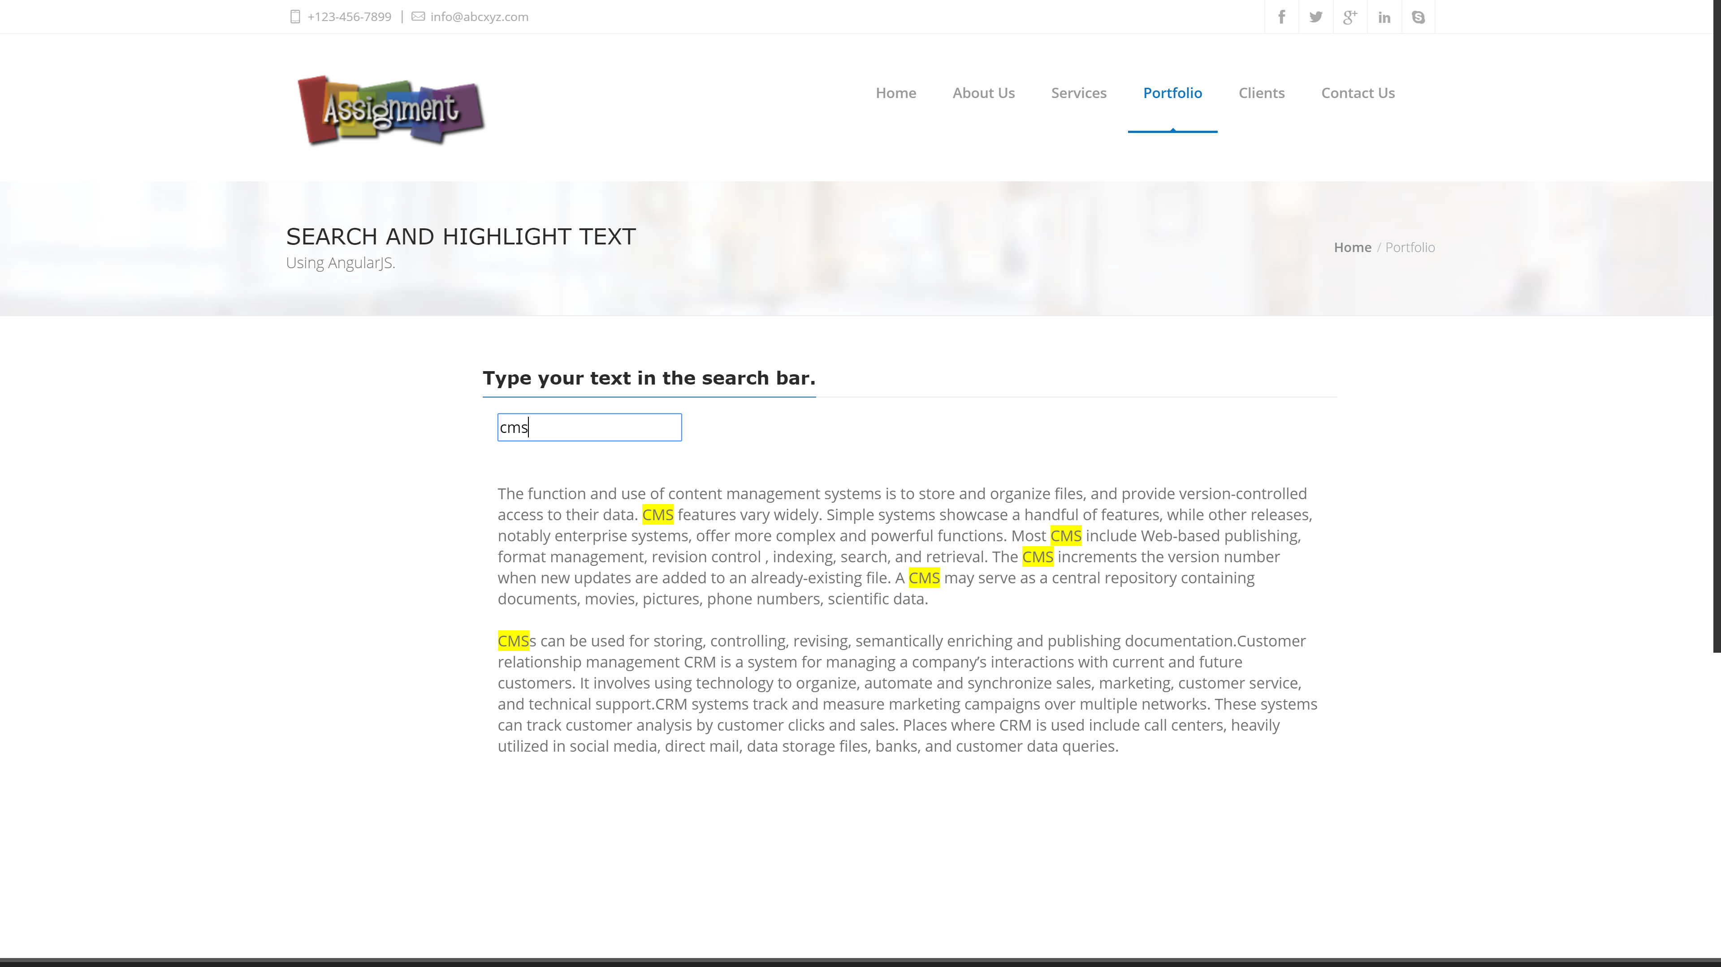

**Sorting Numbers**